A Wireless Method For Monitoring Medication Compliance

Jeffrey S. Jonas
Computer Engineering Department
New Jersey Institute of Technology
Newark, New Jersey
jeffj@panix.com

Abstract—There are many devices on the market to help remind patients to take their pills, but most require observation by a caregiver to assure medication compliance. This project demonstrates three modes to detect pill removal from a pillbox: a switch under the pills, a reflective type photointerrupter and a transmissive “electric eye” photosensor.
Two methods of caregiver notification are demonstrated: text messages transmitted via an attached cellular phone, or the status is collected by a PC which provides an audit trail and daily notification if no pills were taken.
Each mode exhibited blind spots or other failures to detect pill presence but several complimentary combinations of sensors increases the accuracy of pill detection.
Keywords—telemedicine, eldercare, medication compliance

Introduction
Medication compliance is a major problem for people of all ages, not just the elderly. It is easy to forget to take one’s medicine, particularly when there are no immediate benefits or symptoms. “I feel good today” is often the excuse for skipping one’s medication. Many conditions such as high blood pressure have no symptoms and will contribute to serious illness later. Non-compliance (not taking medicine as prescribed) contributes to avoidable illnesses and deaths. Amid the compelling statistics “In 1986, a review of seven studies, conducted in the United States, revealed that 5.5% of hospital admissions, i.e. 1.94 million admissions, can be attributed to drug therapy noncompliance. Their total cost to hospitals was estimated to be around $8.5 billion [1].
There are numerous pill containers available that make it easier to track one’s medicine intake. Some have 1-4 compartments per day for a week’s pre-counted pills, often with embedded timers, alarms or clocks. One model is a carousel that automatically dispenses pills. The most expensive medicine dispenser is about the size of a coffee-maker, holds 60 pre-filled cups and automatically calls a caregiver if medication is not removed or acknowledged [2]. This project seeks to fill the void: a monitored system that is low cost, easy to use yet reliable.

Two Approaches
The first prototype is a variation of the dispensing carousel by using COTS (Commercial Off The Shelf components). A motorized candy dispenser was wired to a wireless transmitter. A wireless mouse, keyboard or game controller could have been easily modified since only a switch closure is required, but a RKE (Remote Keyless Entry) fob was chosen to illustrate that authentication and security is possible if a secure chipset is used. The theory of operation is simple: pressing the button dispenses the medicine and activates the transmitter. A receiver at the PC logs the event and notifies the caregiver if no activity occurs in the prescribed time.
The second prototype is a multiple-compartment pillbox modified with various sensors to detect pills within the compartment. One sensor was used per compartment to isolate their readings. A sensitive microswitch, a reflective photosensor and a transmissive “electric eye” phototransistor and led pair were interfaced to a microcontroller to monitor and filter the inputs and transmit only change of status (pill removed or compartment refilled). The RS232 serial interface connects either to a cellular phone to send SMS (text messages) for stand-alone operation, or to a PC via wire or wireless link. A switch input selects the message format and protocol: plain text to the PC (and for easier observation), GSM commands for the cellular phone text messaging.
The PIC 18f252 was chosen for the on-chip peripherals: 5 channel 10 bit A/D (only 2 were used), reconfigurable I/O pins, on-chip flash ROM for program and data. All the sensors interfaced directly to the PIC, requiring only pullup resistors.

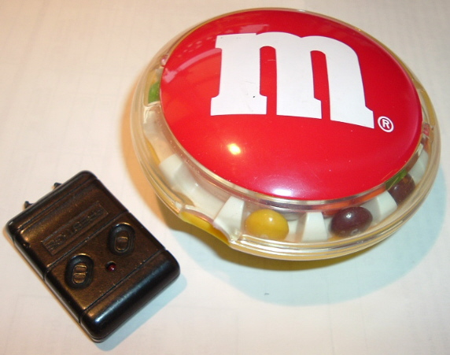

Figure 1. Candy dispenser prototype.

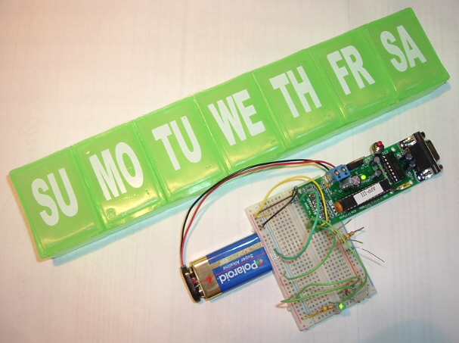
Figure 2. Pill box prototype and controller.

The Microprocessor Module
The Microchip PIC 18f252 microcontroller module is sold as a kit by the Al Williams Company. “APP-III” refers to the 18f252 microcontroller pre-programmed with a boot loader in memory locations 0000-01FF for loading programs into the Flash Rom via the RS232 port without any other equipment. “GPMPU28” refers to the PCB board which is sold with or without parts. It was chosen because it is a totally self contained unit with power supply, oscillator, RS232 port and edge connector for easy breadboarding. Most of the microcontroller’s pins are programmable as input or output. In this application, all the card edge connections are inputs with RA0-1 programmed as analog inputs (internally multiplexed to a single 10-bit analog to digital converter).
A 9 volt battery powers the on-board 5 volt regulator which powers the processor and the external sensors as well.
- PIC Processor Connections
18f252 pin | Module Cconnector | I/O
 | 1 | Ground
2 | 10 | Analog input from reflective sensor
3 | 9 | Analog input from phototransistor
12 | 3 | Digital input from pill sense switch
13 | 2 | Digital input: mode select  (verbose / SMS)
14 | - | Onboard LED
 | 11 | +5 V out
 | Power | 9 volt battery
 | DB9S | RS232C serial interface

The Microswitch
An external sealed switch is preferred to protect against contamination. The snap action provides a mechanical hysteresis to prevent chatter and false signaling, and the lever provides mechanical advantage. The most sensitive switch was chosen from all the parts in stock.

The Reflective Photointerruptor
The Sharp GP2A200LCS is a complete module with only 3 connections: V_{CC}, ground and V_{OUT}. It senses objects from 5 to 15mm and responds to most colors and textures.

The LED and Phototranssitor
A matched infra-red LED and phototransistor pair form an “electric eye” across the bottom of a compartment. The LED is wired to +5 volts via a current limiting resistor. The phototransistor is pulled high via a 10k pullup resistor.
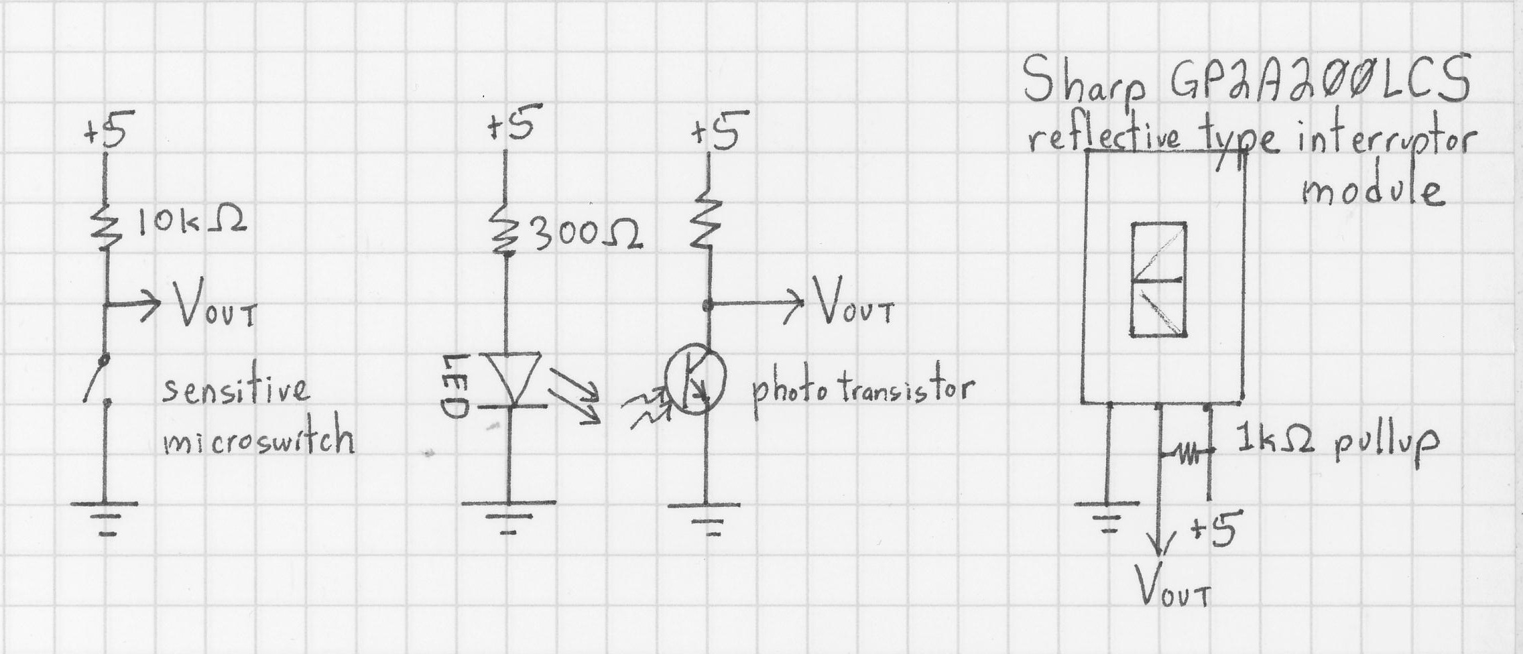
Figure 3. Schematic of pill container sensors.

Assembly
The microswitch was installed underneath one compartment. A false bottom was fitted inside the compartment so any pills inside causes it to sink. A pin protrudes thru the bottom of the compartment and presses the switch lever. The spring from the switch pushes the false bottom back up when empty.
The reflective module mounted on the side of a compartment with a hole for the sensor to view inside.
The Infra-Red LED was press-fitted into a hole near the bottom of the container. A digital camera verified that the beam was aimed directly at the opposite hole for the phototransistor (CCD cameras show infra-red as dark purple). A phototransistor was press-fitted into a hold drilled opposite the LED so the beam crosses the bottom of the compartment. A clear plastic insert forms an inverted “U” to force fills to block the beam.
A small general-purpose PC board was attached to the underside of the pillbox to connect the wiring and contain the required pull-up and current limiting resistors, allowing the cable to connect directly to the PIC module without any other components.

Programming The PIC
The PIC-18 has many advantages over the earlier models (such as the PIC-16) such as a deeper stack and more addressing modes. This allows programming it in the “C” programming language instead of assembly language. The APP-III has a boot loader pre-programmed in protected low ROM. This initially conflicted with the “C” compiler environment, for unlike absolute assembler programs that merely specify a new starting address, compiled languages have a prologue before the actual program for establishing the environment, and depend on a linker to join all the object files with pre-compiled libraries. The linker then maps the relocatable code into absolute ROM and RAM locations, creating the Intel .HEX format file of the binary code that is loaded into the chip. Microchip (the PIC chip manufacturer) supplies the compiler for free, but the configuration to operate with the boot loader which not documented by either Microchip or the kit supplier. After extreme diligence, all the required compiler configuration was gathered from several internet resources. The linker configuration file was modified to start loading the program at address 0x022A instead of 0 (to bypass the boot loader and relocated interrupt vectors), and the prologue startup code was modified for an entry point of 0x0200 instead of ROM address 0x0. The speed of subsequent software development and debugging offset the time spent establishing the compiler environment.
The embedded program does the following every second:
- Toggles the on-board LED to provide a heartbeat: a visual indication of activity.
- Reads the switch and both analog inputs
- If debugging is enabled: print all the values to the RS232 port for calibration and debugging.
- Apply a hysteresis to the analog input to avoid jitter from quantization, sensor error and noise. If it is greater than a high-water-mark, then consider it TRUE. If it is lower than a low-water-mark then consider if FALSE, else use the previous result. The high and low values are defined per sensor.
- For each of the 3 inputs: if it has changed from the previous status, then
  - If a cellular phone is attached (SMS mode set via input pin 2) then invoke the SMS subroutine with the message corresponding to the sensor (number 1, 2 or 3) and condition (pill removed or replaced). The SMS subroutine handles the cell phone dialogue for sending the text message. The message and phone number are pre-compressed in the required format. This results in sending the message to the caregiver’s cellular phone via text-messaging.
  - Else the RS232 port is attached to a PC, so transmit the corresponding plain text status message.
  - Save the current reading so only the next change is reported

The Receiving And ReportingSide
A PC running the Linux Operating System receives the pill box’s status via the RS232 port either by wire or wireless modem. Messages concerning pill removal are time stamped and appended into a log file. Every day (or more often as desired), CRON (the clock daemon) runs a shell script. If the log file shows NO activity since the last time the script was executed then an email message is sent to the caregiver, so the PC must have internet access (by any method: dialup, DSL, WiFi, cable modem). The email can be relayed to the caregiver’s cellular phone if their provider has an email gateway for sending SMS.

Results

Candy Dispenser
The modified candy dispenser was alluring for its simplicity: just 2 wires from the candy dispenser’s switch to the wireless transmitter’s switch and a PC interfaced receiver (which can be as simple as a single output to the PC’s parallel port or serial port’s status line). It can accurately dispense very small pills that are hard to handle or detect by other means. Unfortunately, the candy dispenser uses 1.5 volts and the car fob uses a 12v battery, so an external DPST switch was required to operate both simultaneously without circuit modification. Designing a sensor to active the transmitter upon dispenser activity was already defeating the purpose of using only commonly available parts. The result was a clumsy device.

Pill Container

Calibration
The program’s DEBUG mode displays all the sensor readings to the serial port. The analog to digital converter gives 10 bits, thus a range of 0 – 1023. The reflective optical sensor yields readings of 1017 – 1019 with no pill present, 9 – 11 with a pill present. The phototransitor returns 12 – 14 with no pill present, 26 – 30 with a pill present in high ambient light, >300 with a pill present in the dark.

Cellular Phone Protocol
The cellular phone’s command set is documented in the Siemens C56 User Guide [5] and MC45 Siemens Cellular Engine data sheet [6] but does not elaborate how to compress the data since this particular cell phone’s “send SMS message” command does not support the mode for plain text input. The SMS and Pager Toolkit [7] has a Windows application that sends SMS to a cellular phone attached to the PC’s serial port and logs both sides of the dialogue, showing all commands and responses. All the desired messages “pill removed from compartment 1”, “compartment 1 refilled”, etc. were entered to that program and the cell phone actually send and received the proper text. The commands used to accomplish that were coded as literals in the embedded program, including the recipient’s cellular phone number.
Sending text via a cellular phone requires several commands. New commands cannot be sent until the previous command has completed. This requires a “chat script” where the response to each command is received and examined before the next command is attempted. Since the PIC programming is currently not using interrupts, only polled I/O is available. This means there is no receive buffer and the serial port operates in half duplex (cannot receive and transmit simultaneously). To simplify the code, only one character of the response is examined at a time instead of an entire string, so only the “K” of “OK\r\n” is required

Observed Results
The microswitch was not sensitive enough to detect single pills, even with weight added to the lever. The existing switch could easily be converted to detect lid opened/closed.
The reflective sensor only detects objects directly in front of it. There were “blind spots” in the compartment where pills were not detected. That could be correct by curving the bottom as with the “electric eye” to force pills in front of the sensor, which is also more ergonomic for picking up the pills.
The phototransistor has a ±20° angle of half sensitivity, which admits too much ambient light. An extremely narrow focus would be better. Even then, a blackened tube or tunnel may help to block ambient light since the only light source ought to be the LED aimed directly into the phototransistor. Blinking the LED and applying a missing-pulse algorithm will further
The SMS mode can easily hang if the required response is never received (the on-board LED stops blinking because it is waiting for UART input). Debugging that is difficult because there is no second serial port for observing the conversation to the cellular phone and a protocol analyzer was not available to watch both the transmit and receive serial lines.

Linux receiver
The Linux scripts ran well and sent email when pills were not removed.

Conclusions and Future Plans
The candy dispenser is feasible only if the dispenser and transmitter operate from the same battery or there is a simple way to add another contact to the dispenser’s switch. It requires a receiver within range and offers no assurance the data was received. It may be useful in situations where the house is “well wired” with many access points but is otherwise too unreliable for common use.
The candy dispenser design would benefit from these enhancements:
- Removable tray for cleaning & easy loading.
- Trays with different sized compartments for different sized pills, caplets, etc. .
- Use a wireless device such a garage door opener or Remote Keyless Entry system with strong encryption (such as Microchip’s KeeLoq [3] or Atmel’s RKE [4]) to provide authentication and prevent spoofing or replay attacks.
The modified pillbox shows great potential. While no single sensor was perfect, several could be combined into each compartment for more accurate sensing. For example, a more sensitive switch would detect even one pill even if it moves into a photo sensor’s blind spot.
The Microchip PIC based controller has tremendous capability with the on-chip peripherals for communication and data acquisition. More sensors of other types are easily accommodated by the hardware and programming it in “C” greatly speeds the development process particularly with the support libraries for on-chip and off-chip peripherals.
The multi-chamber pillbox would benefit from these enhancements concerning pill detection:
- Try more positions of the photosensors to detect pills (such as on the bottom of the compartment), perhaps using multiple phototransistors per compartment.
- Use missing pulse detection with the transmissive photo sensor to prevent ambient light interference (the prototype used only the output level with constant illumination). That requires software control of the illuminating LED and additional software to filter the phototransistor’s signal. Unless a low-pin version of the PIC microcontroller is used, it is easy to allocate an output pin to control one LED directly.
- Try other sensors such as pressure, weight, capacitance to detect pill presence. The PIC microcontroller’s analog inputs usually interface with few or no additional components.
- Add tilt and motion sensors to report when it was handled (or knocked over by the cat), and to disable pill status when the box is not level.
- Use the PIC’s interrupt-upon-change feature for the digital switch inputs so the CPU can use SLEEP mode to conserve battery power (it currently busy-loops and polls all inputs). Similarly, enabling interrupts for the analog inputs instead of busy-loops will allow the CPU to SLEEP during peripheral activity. The prototype does not use interrupts because such code is significantly harder to write and debug.
When used with a cellular phone:
- Read the notification phone number from the cell phone’s address book (the phone number was hard-coded in the prototype), thus eliminating any user-interface (number setting and modification is then a function of the cellular phone, not the pill monitor). That preserves the “baby-monitor” model that it’s an appliance with only an on/off switch.
- Allow multiple numbers for notifying several caregivers (only 1 number is currently supported).
- Add a real time clock for time stamping events, and to allow daily notification instead of only real-time notification when pills are removed or refilled. The downside of this is requiring some method of setting the clock and assuring its accuracy since the device should not have any user interface (although a clock display may be considered useful).
- Expand the SMS (text messaging) command processing to a chat script similar to those used to dial modems in HoneyDanBer UUCP. This requires many changes such as converting all I/O from polling to interrupt-driven with a receive buffer, checking the responses for strings instead of a single character, error handling for when the expected reply does not arrive, adding a watchdog timer to prevent blocking when replies don’t arrive, adding a-priori knowledge to handle different command sets from various cellular phone manufacturers and models.
When used with a central monitor:
- Enhance the protocol from transmit-only to one with acknowledgement of transmissions. That will assure that the data was received and verify the communication channel is working.
- Add event logging to the microcontroller (preferably in NVRAM to retain unacknowledged data during battery changes and dead batteries) to allow delayed transmission either upon polling/query from the central monitor or transmission retries.
- If events are not received by the monitor in real time then a real time clock is required to timestamp the events for later retrieval. Unlike the cellular phone scenario, it is reasonable to assume a bi-directional protocol, so the PC could also set the time to assure time synchronization of all data sensors.
- Concealed buttons for the user to selectively permit restricted activities such as resetting the ID or firmware upgrades.
In conclusion, the sensors complimented each other and yields greater accuracy of detecting pills when used in various combinations.

References
- B. Dhillon, Human Reliability and Error in Medical Systems, World Scientific Publishing Company, 2003, pp. 2, 90.
- e-pill Medication Reminders, “Monitored Automatic Pill Dispenser MD.2 with Voice Alarm,” http://www.epill.com/md2.html.
- Microchip KEELOQ Authentication Products, data sheet, 2006, http://www.microchip.com/stellent/idcplg?IdcService=SS_GET_PAGE&nodeId=2074.
- Transparent receiver IC 433 MHz for RKE/TPMS, data sheet, 2006, http://www.atmel.com/dyn/products/product_card.asp?part_id=3961.
- Siemens C56 User Guide, 2002, http://www.comparecellular.com/images/phones/userguide166.pdf.
- MC45 Siemens Cellular Engine, data sheet, http://www.fuschlberger.net/files/flybook/mc45-atcommands.pdf.
- ActiveXperts SMS and Pager Toolkit, http://www.activexperts.com/activsms/.
- P. Ross, “Managing Care Through The Air," IEEE Spectrum, vol 41, number 12, pp. 26-31, December 2004.

