Appendix A

program listings
Appendix A.1 is the embedded “C” language program programmed into the flash memory of a PIC 18f252 microcontroller. It monitors a pillbox using various sensors to detect pill removal, and either transmits plain text message for change of status, or sends the message to a cellular phone attached to the RS232 serial port using the SMS protocol.
The following Linux program and configuration files monitor and report activity from either the candy dispenser or pillbox prototypes:
- Appendix A.2 is the program that receives the wireless status and logs the event into a file.

- Appendix A.3 is the cron configuration file that runs a program to notify the caregiver. Notification may be daily or more often, as desired.

- Appendix A.4 is the daily status program that notifies the caregiver via email or text message.

The Linux software can be modified to operate under Windows using Cygwin or other POSIX environments.

A.1 Source Code: Pill Sensors
/*
* Source code to read pill container sensors
* By Jeffrey S. Jonas
*
* Development environment:
* software:
* The Microchip C18 "C" complier and libraries
* hardware:
* The APP-III GPMPU28 PIC development board by
* AWC Electronics contains
* - 18f252 single chip microcontroller featuring
* . on chip 5 channel A/D (multiplexed input)
* . other pins may be programmed as
* digital input or output
* . on chip UART
* . on chip FLASH, EEPROM and RAM
* - 20MHz resonator
* - RS232 level shifter and DB9S connector
* - 5v regulator powered by a 9v battery
* - 11 pin edge connector for interfacing to devices
* - reset switch, one output-controlled onboard LED
* see: http://www.awce.com/app3kit.htm
*
* PIN ASSIGNMENTS
* +-- 18f252 chip
* | +-- card edge
* | |
* 2 10 AN0 : analog input 0 from pill 1
* reflective photosensor module
* 3 9 AN1 : analog input 1 from pill 2 photosensor
* 12 3 RC1 : digital input: pill 3 compartment switch
* 13 2 RC2 : digital input: mode select
* (verbose / SMS)
* 14 - RC3 : onboard LED
* 17 - RC6/TX: uart transmit to DB9 pin 2
* via rs232 level shifter
* 18 - RC7/RX: uart receive to DB9 pin 2
* via rs232 level shifer
*
* Setting card pin 2 HIGH sets SMS_FORMAT
* so the cellular phone on the RS232 serial port
* sends text messages (SMS) to the
* pre-programmed phone number.
* Setting card pin 2 LOW sends plain text messages
* to the ZigBee wireless adapter (or direct connect cable)
* on the RS232 port to a home PC to log the events
* and send daily status via email or SMS-gateway.
*/

#include <p18f252.h>
#include <stdio.h>
#include <delays.h>
#include <usart.h>
#include <adc.h> // analog input definitions
extern union USART USART_Status;

// external input chooses plain text or SMS messages
const int PILL1_REMOVED=0;
const int PILL1_REPLACED=1;
const int PILL2_REMOVED=2;
const int PILL2_REPLACED=3;
const int PILL3_REMOVED=4;
const int PILL3_REPLACED=5;
const int MODE_MSG = 6;

#define SMS_FORMAT PORTCbits.RC2 // input RC2 chooses SMS or verbose output

// analog input is 10 bits, so the range is 0-1023
const int ANALOG0_HIGH = 220; // define a hysteresis for unambiguous readings
const int ANALOG0_LOW = 200;
const int ANALOG1_HIGH = 220;
const int ANALOG1_LOW = 200;

rom const char * rom const full_message []
={
"pill removed from compartment 1\r\n",
"compartment 1 REFILLED\r\n",
"pill removed from compartment 2\r\n",
"compartment 2 REFILLED\r\n",
"pill removed from compartment 3\r\n",
"compartment 3 REFILLED\r\n",
"Verbose mode\r\n",
"SMS mode\r\n"
};

// the cellular phone command to send a SMS text message
// including the length field
rom const char * rom const sms_cmd []
={
"AT+CMGS=41\r",
"AT+CMGS=33\r",
"AT+CMGS=41\r",
"AT+CMGS=33\r",
"AT+CMGS=41\r",
"AT+CMGS=33\r"
};

// The same messages from "full_message" in PDU compressed format
// as required by cellular phones without plain text SMS support.
rom const char * rom const sms_msg []
={
// pill removed from compartment 1
"0001000B819180551512F200001FF0349B0D9297DB6F7B990C32CBDF6DD0F8DD8687E5F476D94D07C500\032\r",

// compartment 1 REFILLED
"0001000B819180551512F2000016E3771B1E96D3DB65371D1403498BC62493592402\032\r",

// pill removed from compartment 2
"0001000B819180551512F200001FF0349B0D9297DB6F7B990C32CBDF6DD0F8DD8687E5F476D94D07C900\032\r",

// compartment 2 REFILLED
"0001000B819180551512F2000016E3771B1E96D3DB65371D2403498BC62493592402\032\r",

// pill removed from compartment 3
"0001000B819180551512F200001FF0349B0D9297DB6F7B990C32CBDF6DD0F8DD8687E5F476D94D07CD00\032\r",

// compartment 3 REFILLED
"0001000B819180551512F2000016E3771B1E96D3DB65371D3403498BC62493592402\032\r",
};

void put_verbose_message (const int msgIndex)
{
putrsUSART (full_message[msgIndex]);
}

// Cellular phones use a Hayes-modem "AT" command set.
// This handles one command at a time
// by transmitting the command and reading back the reply.
void do_cmd (const char * const command, const char rpy_char)
{
// flush input buffer
while (DataRdyUSART())
{
getcUSART();
}

if (USART_Status.FRAME_ERROR) // clear any rcv errors
{
// printf("Error: FRAME_ERROR\r\n");
USART_Status.FRAME_ERROR=0;
}

// The serial receiver can overrun if data is received
// when not actively polling since it's not
// interrupt driven.
// RCSTA (the Receive Status & Control Register)
// is explained on pg 167 of the 18f252 data sheet.
if (USART_Status.OVERRUN_ERROR || RCSTAbits.OERR)
{
// printf("error: OVERRUN_ERROR\r\n");
USART_Status.OVERRUN_ERROR=0;
RCSTAbits.CREN=0; // clear the overflow error
RCSTAbits.CREN=1; // to allow further data reception
}

putrsUSART (command); // transmit the command string

do // read (and discard) the reply until the terminating character
{
while (!DataRdyUSART()) // wait for character available
;
if (USART_Status.FRAME_ERROR) // clear any rcv errors
USART_Status.FRAME_ERROR=0;
if (USART_Status.OVERRUN_ERROR || RCSTAbits.OERR)
{
USART_Status.OVERRUN_ERROR=0;
RCSTAbits.CREN=0; // clear the overflow error
RCSTAbits.CREN=1; // to allow further data reception
}
} while (getcUSART() != rpy_char);
}

// Send the command sequence for a cellular phone to send a text message (SMS)
// given a pre-formated message in PDU compressed format.
void putSMS (const int msgIndex)
{
do_cmd ("\rATE0\r", 'K'); // command echo OFF, wait for "OK"
do_cmd ("AT+CMEE=1\r", 'K'); // set numeric error codes
do_cmd ("AT+CMGF=0\r", 'K'); // set compressed PDU message format
do_cmd (sms_cmd [msgIndex], '>'); // send SMS command, wait for prompt
do_cmd (sms_msg [msgIndex], '\r'); // send SMS message, wait for completion
}

void
main (void)
{
// int i = 0; // debug only

int sensor0, sensor1; // the analog inputs

// Save the previous pill compartment states to report only changes
// Set initial status to EMPTY
// so all filled compartments are reported on power on.
int pill_1_status = PILL1_REMOVED;
int pill_2_status = PILL2_REMOVED;
int pill_3_status = PILL3_REMOVED;

int new_status;

// set uart to 9600 async
OpenUSART (
USART_ASYNCH_MODE & USART_EIGHT_BIT & USART_TX_INT_OFF &
USART_RX_INT_OFF & USART_BRGH_HIGH, 129);

// open 2 analog channels
OpenADC (ADC_FOSC_32 & ADC_RIGHT_JUST & ADC_8ANA_0REF,
ADC_CH0 & ADC_CH1 & ADC_INT_OFF);

TRISCbits.TRISC3 = 0; // set on-board LED port to output

while (1)
{
Delay10KTCYx(0);
Delay10KTCYx(0); // spin-loop delay one second

PORTCbits.RC3 ^= 1; // toggle on-board LED

// Read all sensor status at the same time to assure coherency
// particularly since transmitting SMS may take several seconds.

// Read analog channel 0 for photo sensor
SetChanADC (ADC_CH0);
Delay10TCYx (10); // Delay for select channel
ConvertADC (); // Start conversion
while (BusyADC()); // Wait for completion
sensor0 = ReadADC(); // Read result

// read analog channel 1 for photo sensor
SetChanADC (ADC_CH1);
Delay10TCYx (10); // Delay for select channel
ConvertADC (); // Start conversion
while (BusyADC()); // Wait for completion
sensor1 = ReadADC(); // Read result

#if 0 // debugging
if (!SMS_FORMAT)
printf ("%d (%d %d %#x) mode=%S",
i++,
sensor0, sensor1, PORTCbits.RC1,
full_message[MODE_MSG + SMS_FORMAT]);
#endif

// examine the switch input
if (PORTCbits.RC1)
new_status = PILL3_REPLACED;
else
new_status = PILL3_REMOVED;

if (new_status != pill_3_status)
{
if (SMS_FORMAT)
putSMS (new_status);
else
put_verbose_message (new_status);

pill_3_status = new_status; // save the status for next loop
}

// process previously read analog input 0
if (sensor0 > ANALOG0_HIGH) // apply hysteresis
new_status = PILL1_REPLACED;
else
{
if (sensor0 < ANALOG0_LOW)
new_status = PILL1_REMOVED;
else
new_status = pill_1_status; // use previous status
}

if (new_status != pill_1_status) // send message only on change of status
{
if (SMS_FORMAT)
putSMS (new_status);
else
put_verbose_message (new_status);

pill_1_status = new_status; // save the status for next loop
}

// process previously read analog input 1
if (sensor1 > ANALOG1_HIGH) // apply hysteresis
new_status = PILL2_REPLACED;
else
{
if (sensor1 < ANALOG1_LOW)
new_status = PILL2_REMOVED;
else
new_status = pill_2_status; // use previous status
}

if (new_status != pill_2_status) // send message only on change of status
{
if (SMS_FORMAT)
putSMS (new_status);
else
put_verbose_message (new_status);

pill_2_status = new_status; // save the status for next loop
}
}
}

A.2 Source Code: Wireless Status Reception
# log_event.sh
# this shell script is invoked every time
# the key fob transmits that pills are being taken

LOGFILE=$HOME/medicine.log
date >> $LOGFILE

A.3 Crontab Configuration File
# This is the crontab file that runs the
# notification program every day.
#
# the command
# crontab crontab_file
# needs to be run only ONCE
# to start the recurring execution
# This file is expected to be edited as needed with
# - times for notification [the crontab schedule line]
# - email of the caregiver(s) [MAILTO variable]
# - message to be delivered [MSG variable]

# mail the warning to Jeff's cellular phone
# via the Cingular SMS gateway
MAILTO=9085551212@mmode.com

# use /bin/sh to run commands,
# no matter what /etc/passwd says
SHELL=/bin/sh

# the key fob's activities are logged here
LOGFILE=$HOME/medicine.log
TIMESTAMP_FILE=$HOME/pill_notify_timestamp

JOB2RUN=$HOME/bin/daily_job.sh

# check medication status every day at 8:02 PM
MSG="Jeff missed his daily medication, please check up!"
2 20 * * * $JOB2RUN >> $HOME/tmp/cron_out 2>&1

# check medication status at noon and 8:00 PM
# sending different messages
# 0 12 * * * $JOB2RUN MSG='Jeff missed his NOON pill'
>> $HOME/tmp/cron_out 2>&1
# 0 20 * * * $JOB2RUN MSG='Jeff missed his NIGHT pill'
>> $HOME/tmp/cron_out 2>&1

A.4 Source Code: Daily Status

# daily_job.sh
# Send an email to the caregiver
# if no pills were taken since last time this was executed.
# This is invoked automatically every day as needed.

if [ ! -e $LOGFILE ]
then
echo "logfile initialized by $0" > $LOGFILE
exit 1
fi

# Send notification if no pill activity was logged
# since the last time this was run.

if [ $LOGFILE -ot $TIMESTAMP_FILE ]
then
echo $MSG | mail $MAILTO
fi

# Remember when this was run
# for the next execution.

touch $TIMESTAMP_FILE

APPENDIX B

PIC 18f252 kit
The Microchip PIC 18f252 microcontroller module is sold as a kit by the Al Williams Company. “APP-III” refers to the 18f252 microcontroller pre-programmed with a boot loader in memory locations 0000-01FF for loading programs into the Flash Rom via the RS232 port without any other equipment. “GPMPU28” refers to the PCB board which is sold with or without parts. It was chosen because it is a totally self contained unit with power supply, oscillator, RS232 port and edge connector for easy breadboarding. Most of the microcontroller’s pins are programmable as input or output. In this application, all the card edge connections are inputs with RA0-1 programmed as analog inputs (internally multiplexed to a single 10-bit analog to digital converter).
Table B.1 GPMPU28 Connections
JP1 Pin | Signal | IC1 Pin
1 | Ground
2 | RC2 | 13
3 | RC1 | 12
4 | RC0 | 11
5 | RA5 | 7
6 | RA4 | 6
7 | RA3 | 5
8 | RA2 | 4
9 | RA1 | 3
10 | RA0 | 2
11 | +5 V

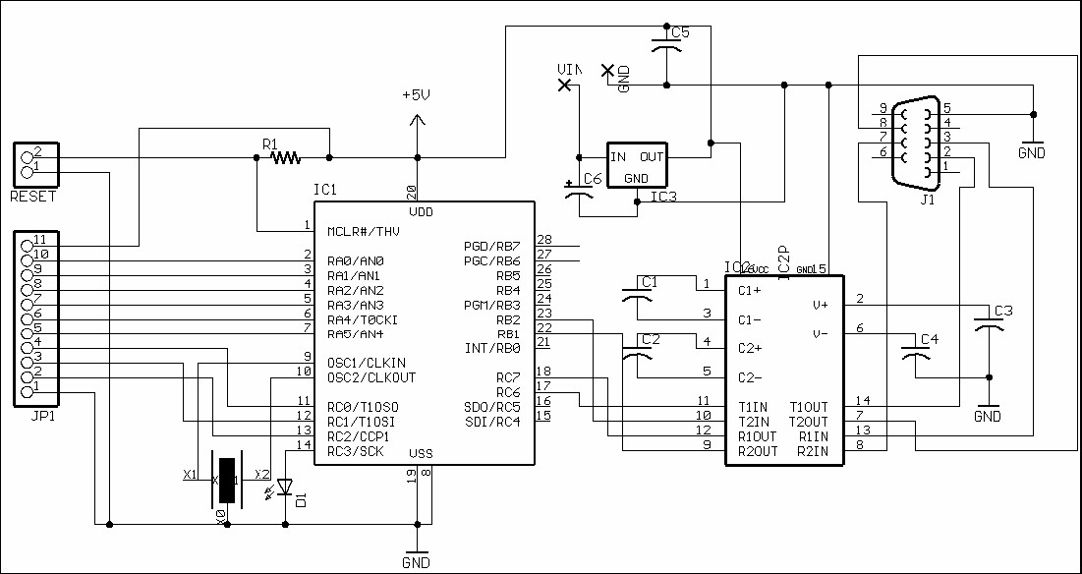

Figure B.1 GPMPU28 schematic.

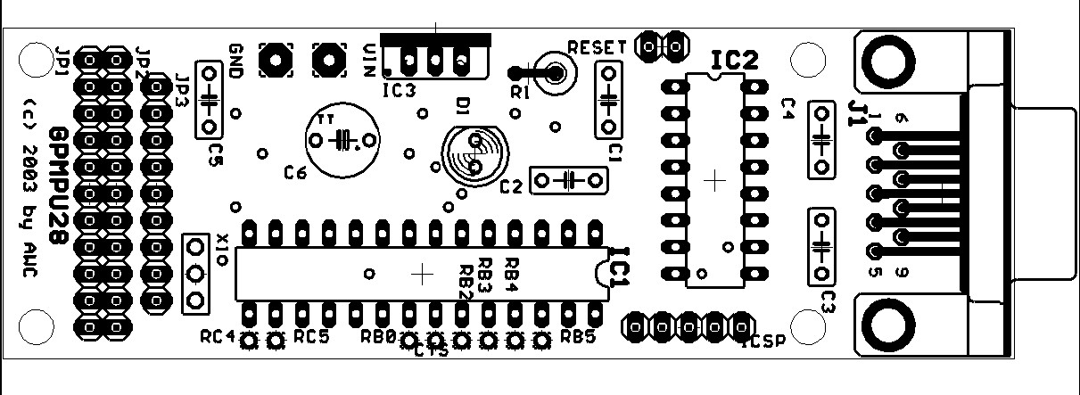

Figure B.2 GPMPU28 board layout.

APPENDIX C

IEEE standards for pans
Table C.1 IEEE Wireless Standards
Standards Committee | IEEE 802: LAN/MAN Standards Committee
Working Group | IEEE 802.11: WLAN Working Group | IEEE 802.15:  WPAN Working Group
Task Group | 802.11a/b/g | 802.15.1: WPAN/Bluetooth | 802.15.3a:  WPAN High Rate/UWB | 802.15.4: WPAN Low Rate/Zigbee
Promoter / Industry Alliance | Wi-Fi: Cisco, 3Com, Agere, Intersil, Compaq, Dell, Sony, Nokia, Symbol, etc. | Bluetooth SIG: Ericsson, 3Com, IBM, Intel, Motorola, Nokia, Agere, Toshiba, etc. | Wi-Media: Appairent, HP, Motorola, Philips, Samsung, Sharp, XtremeSpectrum | Zigbee Alliance: Honeywell, Invensys, Mitsubishi, Motorola, Philips, etc.

